SERVICE NOW PROJECT DOCUMENTATION

Cafeteria Menu Display

Project Documentation

Submitted By
Team ID: LTVIP2026TMIDS79115

Team Size: 3
Team Leader:
Elipe Mounika

Team Members:
Tarun Kumar Anegondi,
Sai Phaneendra Varma Penmetsa.

Mentors Industry Mentor:
No Mentor Assigned

Faculty Mentor:
Narayana

Internship / Organization
SmartInternz – Project Phase

Platform Used
ServiceNow Platform

Academic Year
2025 – 2026

Introduction

Digital transformation has become essential for improving operational efficiency in organizations. Many institutions still manage cafeteria menus manually using printed notices, spreadsheets, or verbal communication. This traditional approach often results in outdated information, lack of transparency, and difficulty in updating menu changes in real time.

To overcome these limitations, the Cafeteria Menu Display System is developed using the ServiceNow platform. The system automates menu management, allowing administrators to create, update, and publish menu details digitally. Employees can view daily and weekly menus through a centralized portal.

This solution replaces manual menu handling with a structured, workflow-driven automation system.

Project Objectives

The Cafeteria Menu Display System focuses on:

- Digitizing cafeteria menu management
- Eliminating manual updates and paper notices
- Providing centralized access to menu information
- Enabling structured data storage
- Creating reports for analysis
- Improving communication transparency
- Enhancing employee dining experience
- Ensuring secure and role-based access

Project Overview

The Cafeteria Menu Display System is a Scoped Application developed within ServiceNow Studio. The system allows administrators to:
- Add daily menu items
- Specify meal types (Breakfast, Lunch, Dinner)
- Set menu prices
- Provide food descriptions
- Publish menu details Users can:
- View available menu items
- Check meal type and price
- Access updated information in real time Previously, cafeteria management involved:
- Manual whiteboard updates
- Printed menus
- No centralized record
- No historical tracking This caused:
- Confusion among employees
- Lack of transparency
- No audit history
- Delayed communication

The implemented system resolves these issues through structured database design and automated functionality.

System Architecture
The system follows a layered architecture within the ServiceNow platform.

Presentation Layer

The presentation layer is implemented using:

- Classic UI
- Service Portal (optional) Users interact with:
- Cafeteria Menu module
- List view of menu items
- Menu record form
- Reports

The interface is user-friendly and responsive. User flow:
  - User logs into instance
  - Opens Cafeteria Menu module
  - Views available menu records
  - Checks details such as meal type and price

Business Logic Layer

Business logic is implemented through:

- Table configuration
- UI Actions
- Reports
- Service Catalog (if implemented) The application ensures:
- Data validation
- Structured input

- Controlled access
- Automated notifications (if configured)

Conditional logic ensures only valid menu data is stored.

Data Layer

The system uses a custom table created inside the scoped application. Primary table:
- Cafeteria Menu (custom table) Fields created:
- Menu Name – String
- Date – Date
- Meal Type – Choice
- Description – String
- Price – Decimal

Each record represents one menu item. The system maintains:
- Record history
- Created by information
- Updated timestamps
- Audit tracking

All data is stored securely within the ServiceNow database.

Implementation Details
The implementation was carried out in structured phases.

Phase 1: Instance Creation

- Logged into ServiceNow Developer Portal.
- Requested a personal developer instance.
- Logged into the instance using administrative credentials.
- Verified system readiness for application development.
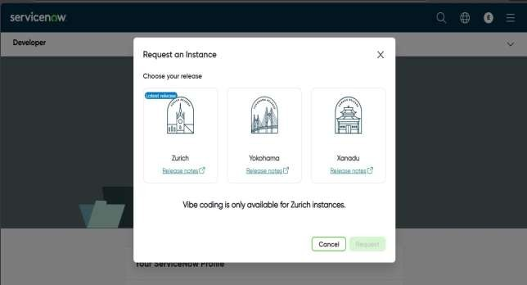
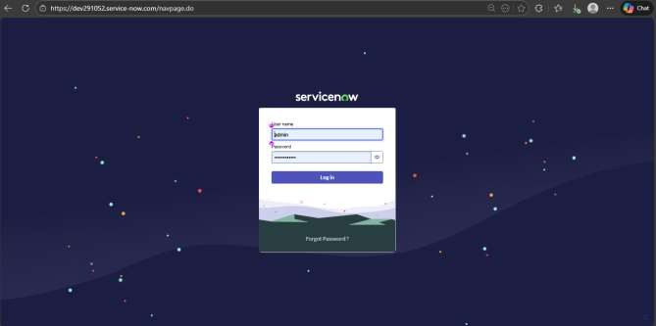

Phase 2: Application Creation Using ServiceNow Studio:

- Created a new scoped application to isolate project components.
- Selected "Create from Scratch" to build a custom solution.
- Application Name: Cafeteria Menu Display.
- Scope: x_1917490_cafete.
- User Experience: Classic ServiceNow
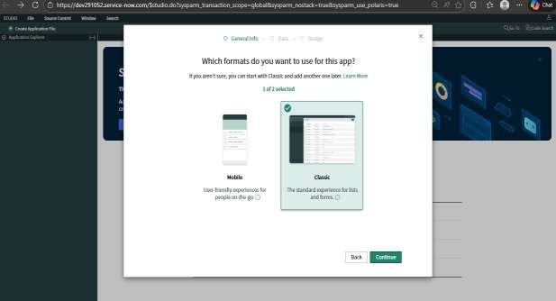
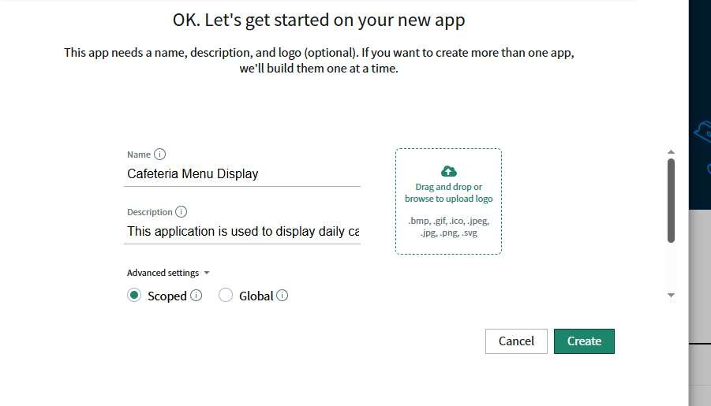

Phase 3: Table Creation Created a custom table to serve as the data foundation:

- Table Name: Cafeteria Menu.

Fields added:
  - Menu Name (String): Used to identify the specific menu title.
  - Menu Date (Date): Used to schedule the menu.
  - Menu Items (String/Multi-line): Detailed description of food offerings.
  - Status (Choice): Lifecycle field initialized as "Draft".

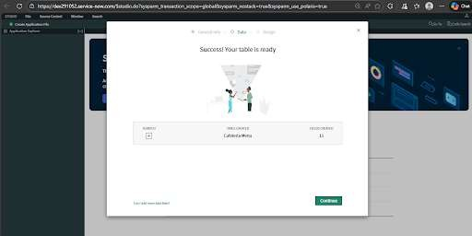

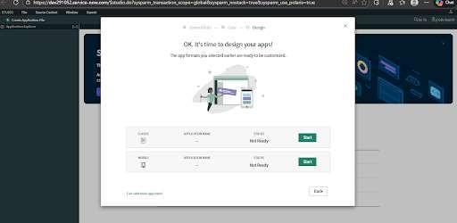

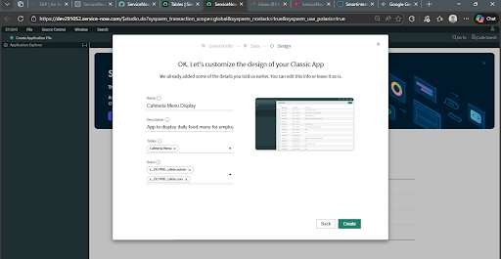

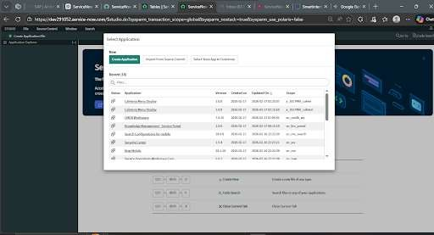

Phase 4: Module Creation Created navigation modules for the application menu:

- Title: Cafeteria Menu.
- Linked Table: Cafeteria Menu (x_1917490_cafete_cafeteria_menu).
- Modules: Included "All" and "Create New" for efficient record management.

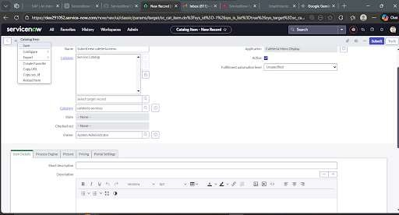

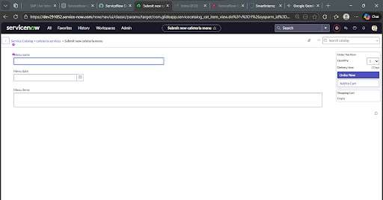

Phase 5: Report Creation Reports were generated to provide business intelligence on cafeteria data.

Report Types:
  - Bar Chart: Visualized the count of menu entries per date.
  - Pie Chart: Analyzed the distribution of menu statuses (Draft vs. Published).
- These reports were pinned to a central Dashboard for real-time monitoring.

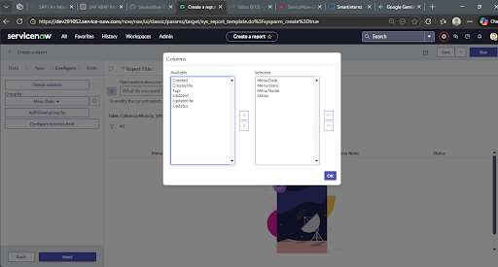

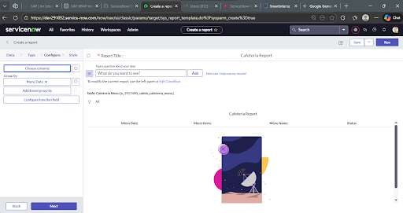

Phase 6: UI Action Implementation A custom UI Action button was developed to automate the publishing workflow:

- Button Name: Mark As Repaired.

Functionality:
  - Programmatically updates the Status field to "Published".
  - Displays a confirmation message: "Menu has been marked as Published".
  - Automatically refreshes the form to show the updated state.

This implementation successfully automates the lifecycle of menu management from initial entry to public availability.

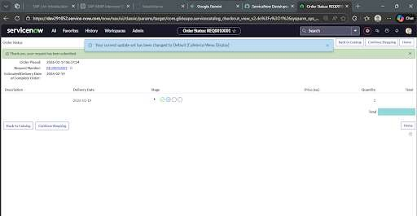

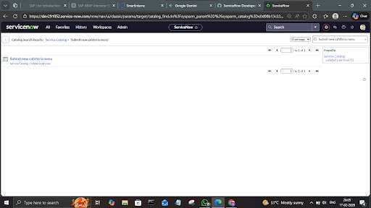

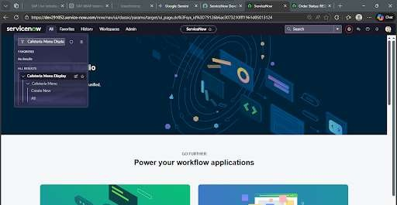

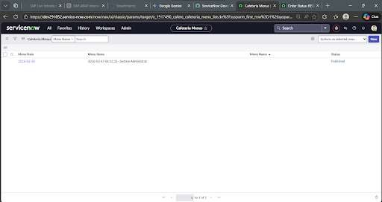

Process Flow Lifecycle
The core logic of the application was defined using a structured process flow to ensure data integrity from submission to publication.

- Trigger Mechanism: The process begins when a user submits the "Submit new cafeteria menu" Catalog Item.
- Initial State (Draft): Upon submission, the system automatically creates a record in the
Cafeteria Menu table with the status set to "Draft".
- Verification Node: The record remains in the administrative list view until a manager verifies the "Menu Name," "Menu Date," and "Menu Items".
- Automation Logic (UI Action): The process flow utilizes a custom UI Action ("Mark As Repaired") to handle the state transition.
- Final State (Published): Once the UI Action is triggered, the status is updated to
"Published," and a system notification confirms the successful completion of the flow.

Testing and Validation
Comprehensive testing was conducted to validate the end-to-end process flow.

- Catalog Workflow Test: Verified that the "Order Now" action correctly initiates the record lifecycle.
- State Transition Test: Confirmed that the Mark As Repaired button correctly executes the script to update the record status.
- Dashboard Validation: Ensured that the Bar and Pie charts accurately reflect the transition of records from "Draft" to "Published".

Challenges and Future Enhancements
- Challenges: The primary challenge involved troubleshooting active filters in the list view that occasionally hid newly created records. This was resolved by clearing the breadcrumb filters during testing.
- Future Enhancements: Proposed updates include adding Email Notifications to alert staff when a menu is published and integrating Mobile Agent capabilities for cafeteria managers.

Conclusion
The Cafeteria Menu Display project successfully demonstrates the capability of ServiceNow to automate organizational workflows beyond standard IT tasks. By digitizing the menu management process, the system provides:

- Transparency: Real-time visibility into meal schedules.
- Efficiency: Automated status updates that reduce manual record editing.
- Scalability: A robust framework that can be expanded to include multiple cafeteria locations or nutritional tracking.

